Design Constraints of Large Scale 3D Printers
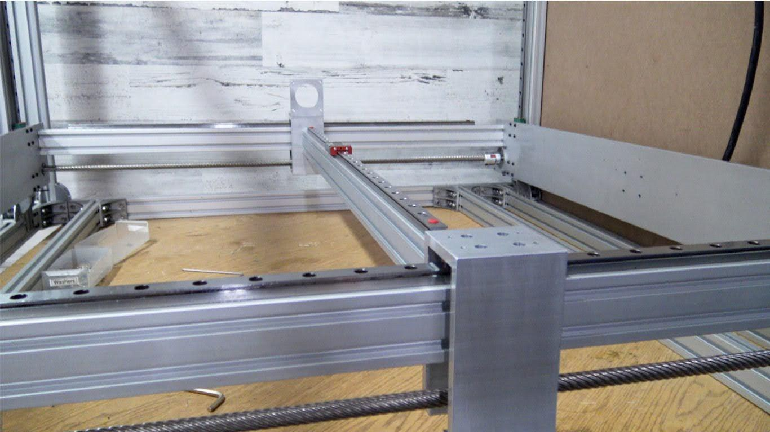

Design Constraints of Large Scale 3D Printers
Large Scale 3d printers can be much more challenging to get the same performance as smaller machines due to rigidity, deflection, resonance, and smoothness of gantry or bed motion.
This relates to the typical speeds and forces applied to mechanical components while in motion.

The idea is to reinforce areas that experience more force or deflection without increasing gantry weight or over designing in a way that may introduce mechanical binds or resonance. The best thing to do is keep the mindset that the printer you’re designing is going to be built to print “X.” Do you want a printer that prints long but short parts or do you want a printer that prints tall parts. You can increase all three directions but that’s where things get more challenging for repeatability and acquiring the needed speeds and quality. It’s totally possible and the many problems that may be introduced can be designed around.

1000mm x 1000mm x 1000mm
Regarding the frame rigidity, I would just suggest larger width extrusions depending on the length and adding gussets where needed. The only reason I go into such detail is because I get a lot of requests from people wanting me to design a printer with a “1000mm x 1000mm x 1000mm build area. The trick is to avoid the sacrifice of performance, speed and repeatability which becomes more and more challenging. The last thing you want is a really big printer that’s really slow or has repeatability problems. You may or may not have the necessary design solution to avoid this scenario. From my experience the challenge is balancing rigidity, repeatability and reliability without exponentially increasing the price. Whether you’re aiming for a moving bed or moving gantry you need to add rigidity without over constraining the motion.

Bed Leveling-Large Print Bed
You’ll experience this in z-axis repeatability between prints and bed leveling. For example, you probe your bed with an auto level routine followed by a mesh leveling routine. Everything is perfect depending on the flatness of your bed compared to rigidity of the overall system. Then the bed probe routine is followed by a G28 homing of the z-axis. An over-constrained bed or gantry may experience some repeatability issues after traveling home and returning to the print surface which will result in a bad first layer. But let’s assume everything is good. So proceed to print your object. After the object is finished the next step is to remove the object. A larger object is going to be more difficult to remove and the process of removal will result in forces applied to the bed or gantry which will cause the bed or gantry to experience some sort of misalignment. So the following print will experience some sort of bed leveling issue resulting in a bad first layer. But your first layer is the most critical and will affect the rest of the print such as warping from bed adhesion or the object becoming loose from the bed. The longer the print takes the more critical layer adhesion becomes. But you can minimize this chain reaction by re-probing the bed before each print. But this takes a long time due to the increased number of points the probe maps out. You could reduce the number of points but a larger print bed will include more dips and peaks from stresses or bows. So you have to maximize the number of points used in probing so that the machine can compensate for each to get that first layer. Another issue to prepare for is the environment’s effect from the introduced heat of the printed object relative to the dimensional stability of the mechanical components and bed.
I get a lot of emails from people wanting to build large printers and from my experience it gets tricky and many people underestimate the challenges. You may or may not know what you’re in for or you may even be able to give me some pointers. Let me know what you think because I really have a lot to learn myself in building these larger printers and I’m open to suggestions on machine design or approaching these issues.

Also See
Duet3D Setup
Design Constraints
3D Distributed

Related Content

3D Distributed

WorkHorse 3D Printer

Duet3D

WorkHorse 3D Printer BOM

WorkHorse 3D Printer BOM Spreadsheet

WorkHorse 3D Printer

WorkHorse CAD

Openbuilds

Autodesk

